C.V.
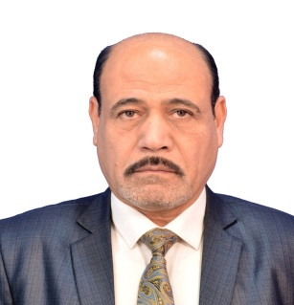

Personal information:
Nadhim Tuhaily Salim | Full Name
Al-Abais | Surname
Iraqi | Nationality
A18158750 | passport
15/ 01 / 1966 | Date of birth

Occupation:
Workplace | The scientific title | Position
Al-Qasim Green University-College of Science | Lecturer | College of Science

Academic Qualifications:
Qualification | Specialization | Place of issue | Year  Obtained
B.Sc | English department | Faculty of education,  Al-Qadisiyah University | 1995
Master | Method of English teaching | Faculty of humanities, University of Ferdowsi, Iran | 2017

Master, thesis title
The role of cooperative learning in Iraqi secondary school EFL learners ' willingness to write and their writing achievement.

Training experience:
I have been teaching English language for 29 years. 26 years in different high school and three years ago I transferred to Al-Qasim Green University-College of Science. I have been doing the same experiences to get or produce high-quality education for students.

Some of them are follows:

1-Develop interactive lesson plans to deliver high-quality education for students.

2-Manage students' behavior while developing and teaching strategies of English language support students' self-control.
3-Formulate and implement rules for behavior and procedures of teaching English language for maintaining a well-disciplined learning environment.
4-Assess students' skills while learning english to determine their needs and develop effective teaching plans particular to each student's abilities.
5-Facilitated students' presentations while providing interventions and methods on how they manage their presentations in a front of their friends.

Published research (Scopus).
Research Title | Journal name
The Effect Of Anxiety In English Tests As A Foreign Language On Both Females And Males Students In Iraqi University. | Journal of Positive School Psychology
The Impact of Anxiety on Students Learning Speaking Skill in Iraqi University | International Journal of Early Childhood Special Education

Languages:
Persian | English | Arabic

Titles:
Conservatism | Telephone number | Email
Babel | 07830415581  07805867696 | Nadhim.T.S@science.uoqasim.edu.iq

